# Design Patterns and Refactoring

## Phase-2

**Group Members:**

Muhammad Umar Hayat 16030011

Muhammad Feroze Waris 16030012

Muhammad Qasim Hunain 16030056

Hassaan Fayyaz 16030009

## Note : The given snapshots are taken from change management tool(Git). Lines with red background are the original source code lines which needed to be refactored and lines with green background are the refactored version of the code.

1 - Variable names updated

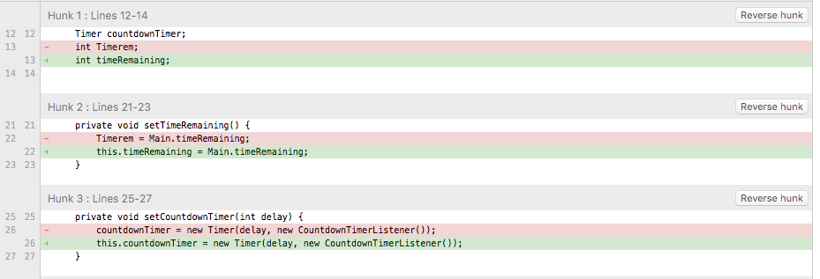

2 - Extract Method

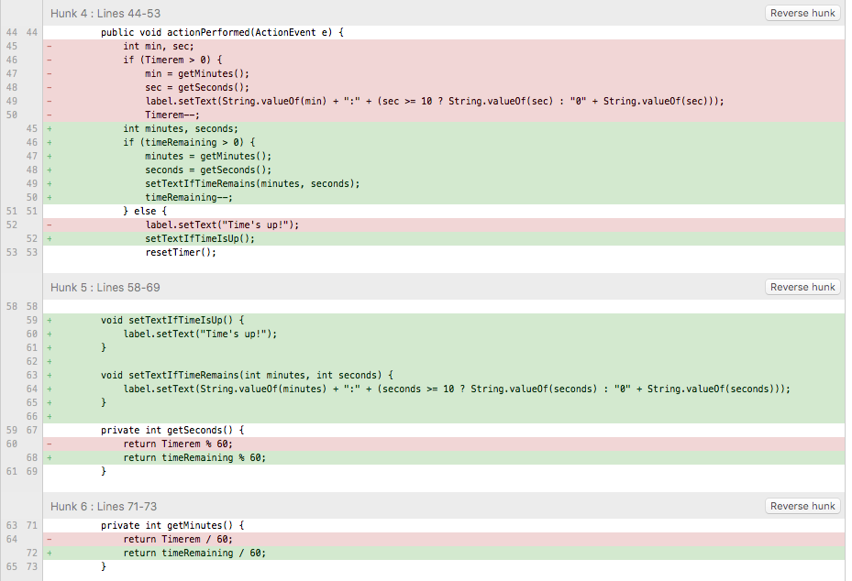

3 – Extract Method

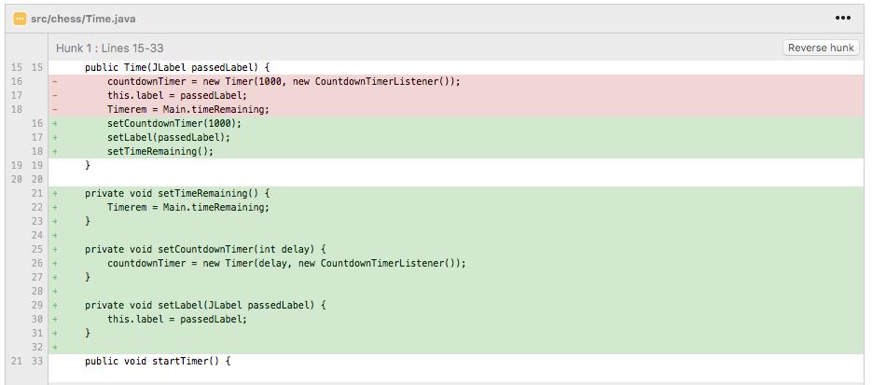

4 – Extract Method

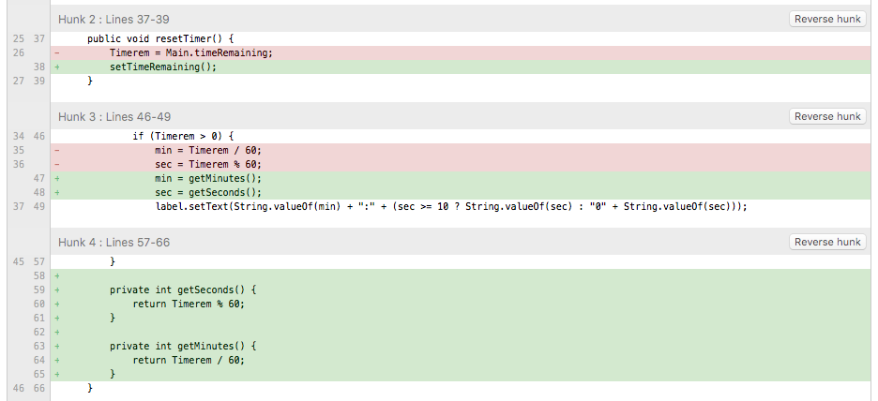

5 – Extract Method

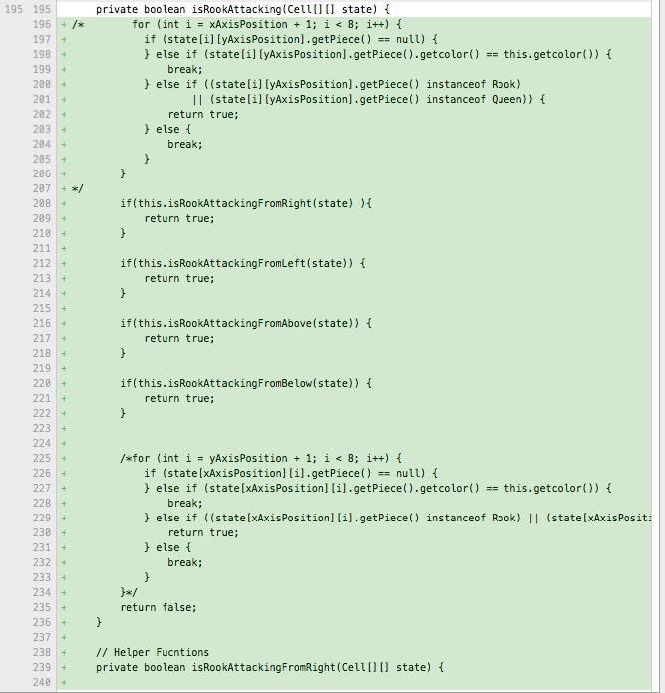

6 – Extract Method

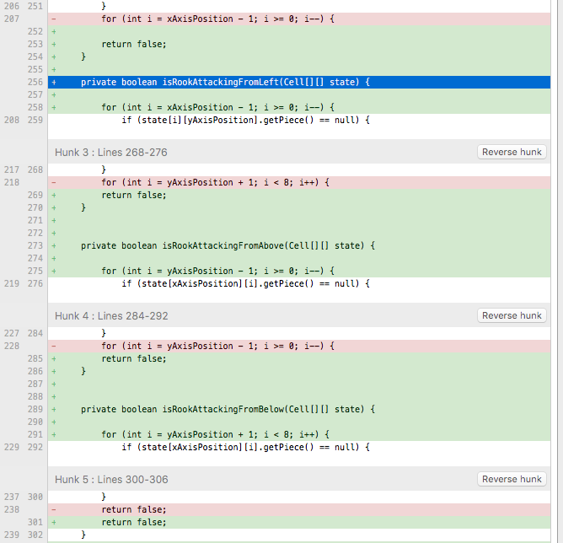

7 – Variable naming convention followed

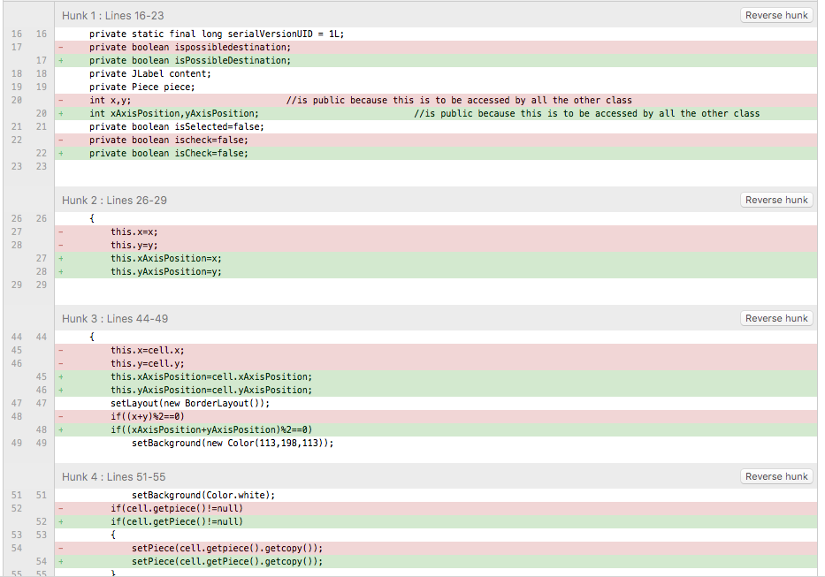

8 – Variable naming convention followed with Extract Method

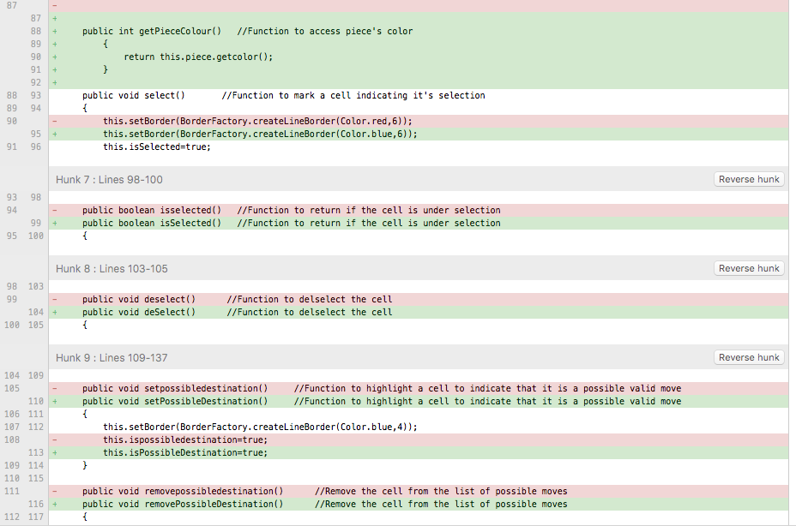

9 – Code Indentation Improved

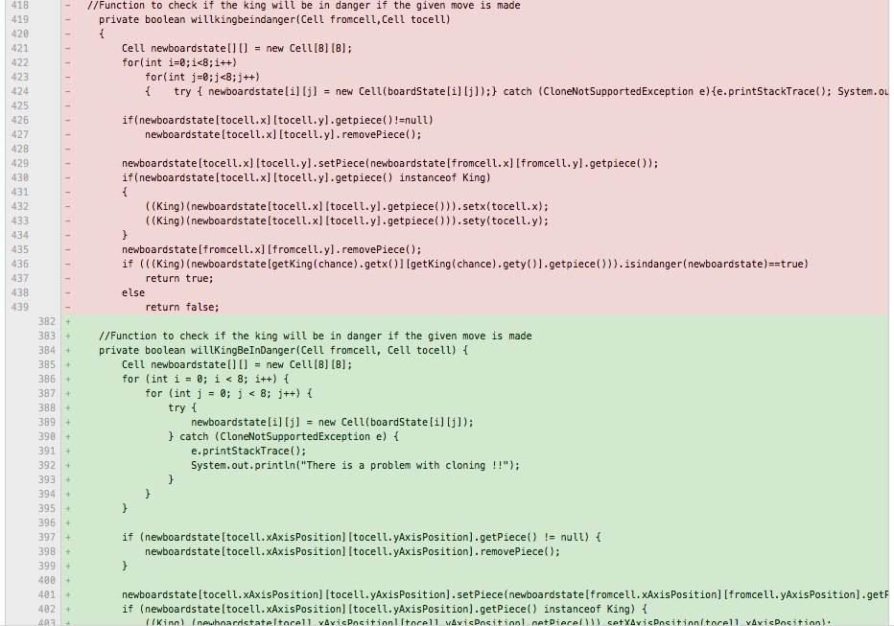

10 – Code Indentation Improved

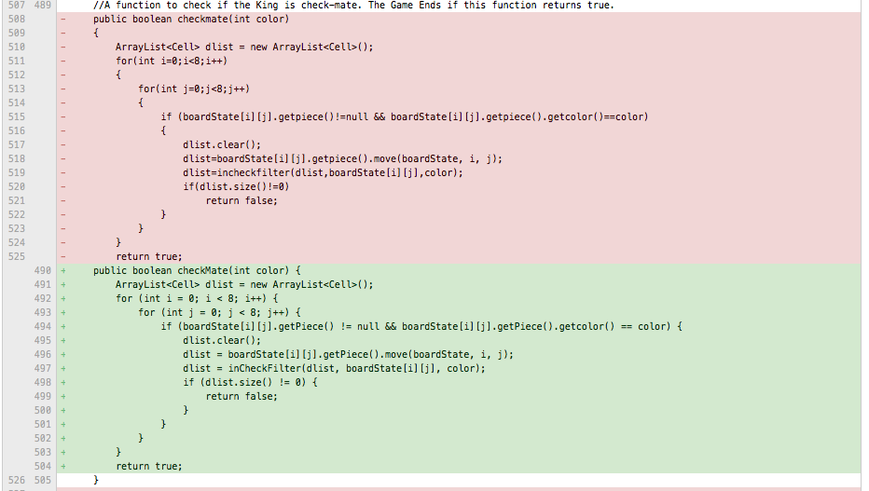

11 – Variable names changed for better readability

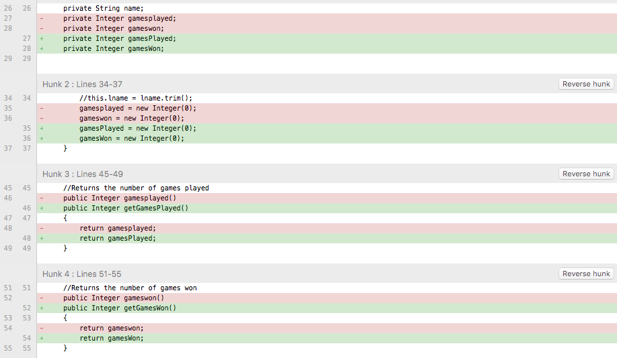

12 - Variable names changed for better readability

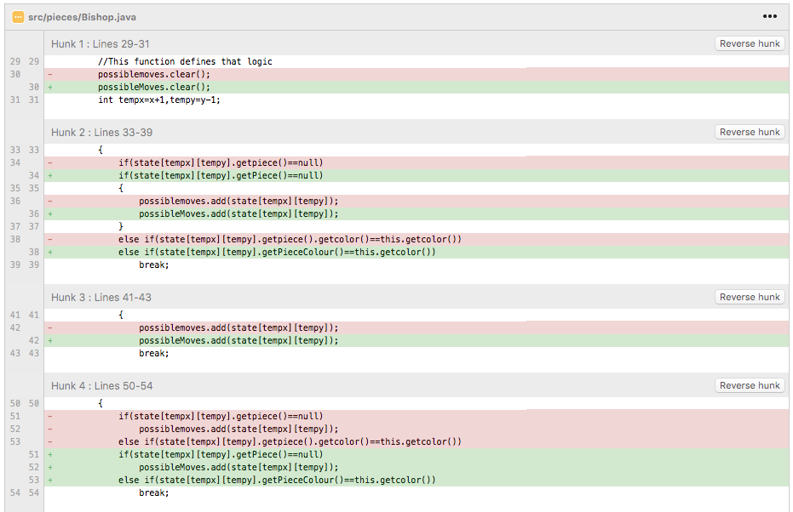

13 - Variable names changed for better readability

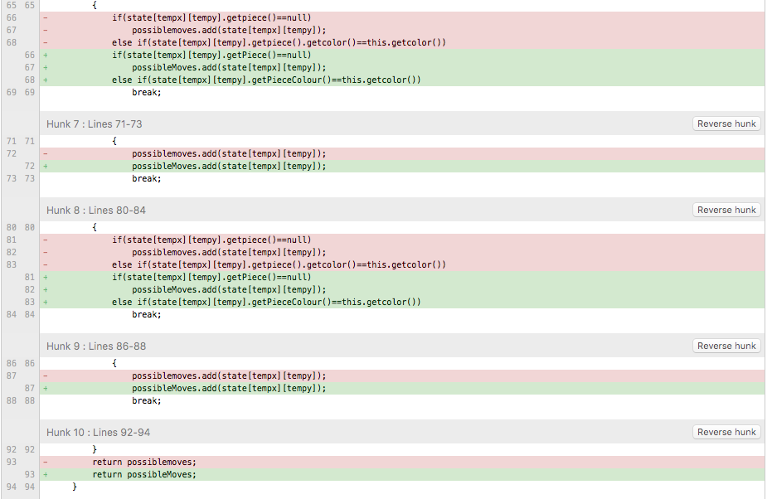

14.a - Variable names changed for better readability

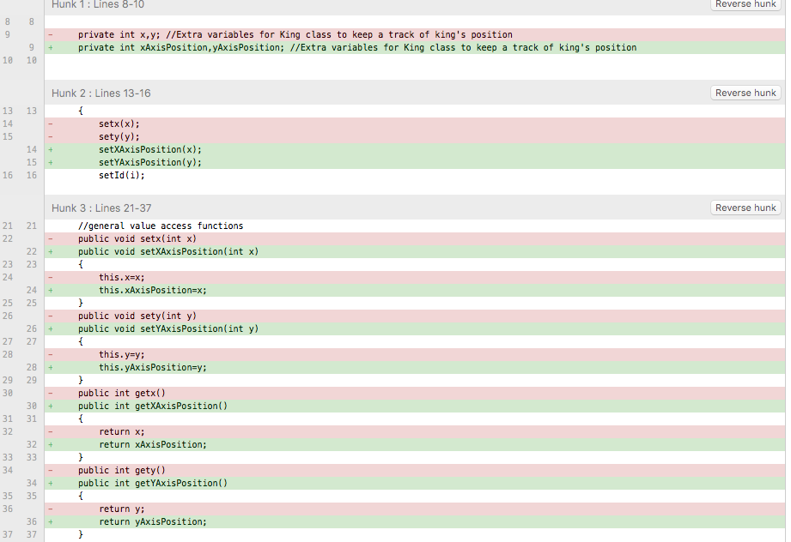

14.b

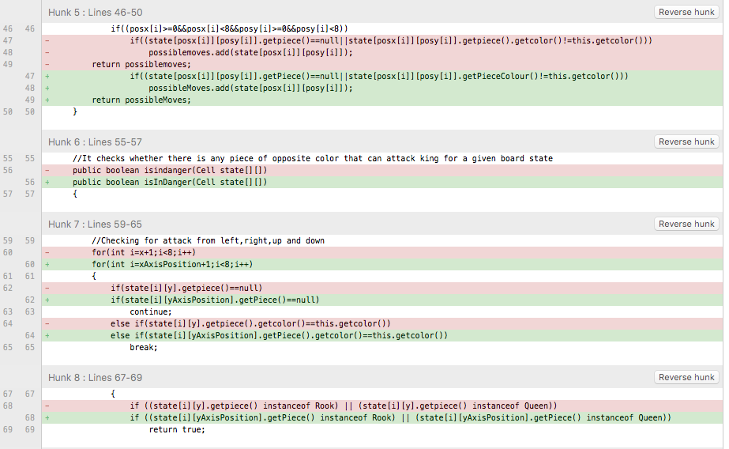

14.c

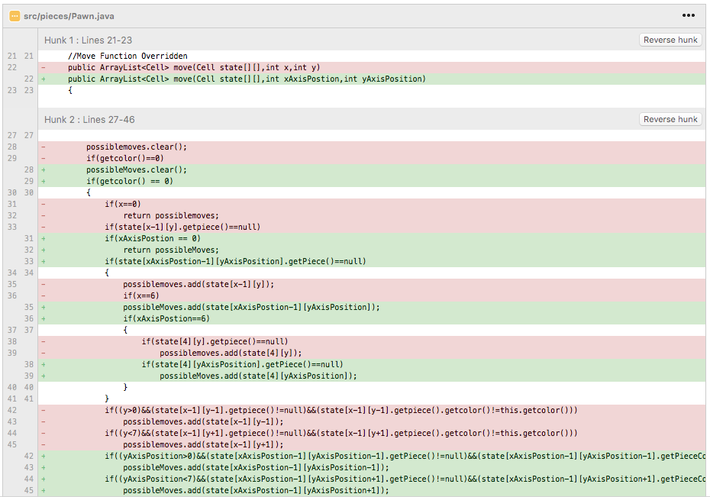

14.c

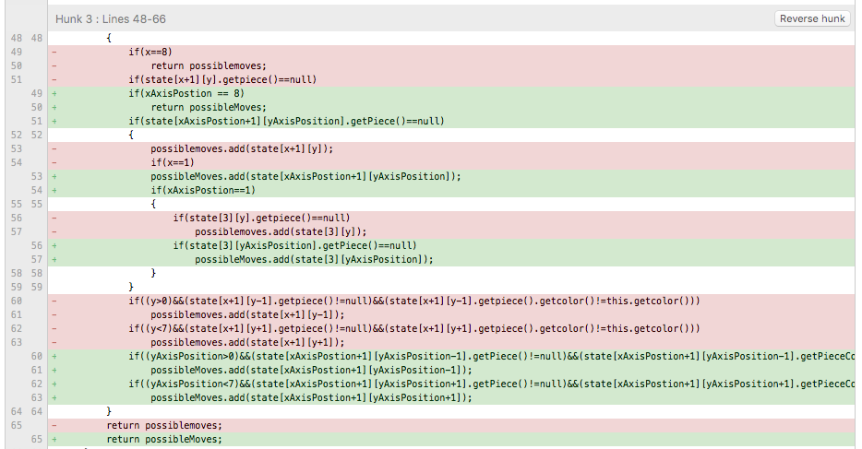

14.d

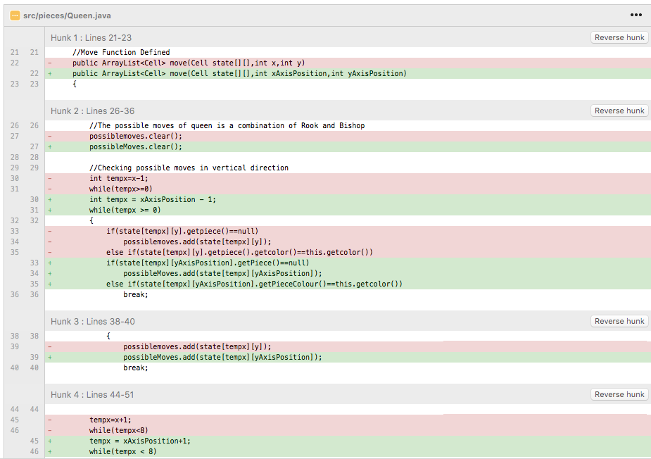

14.e

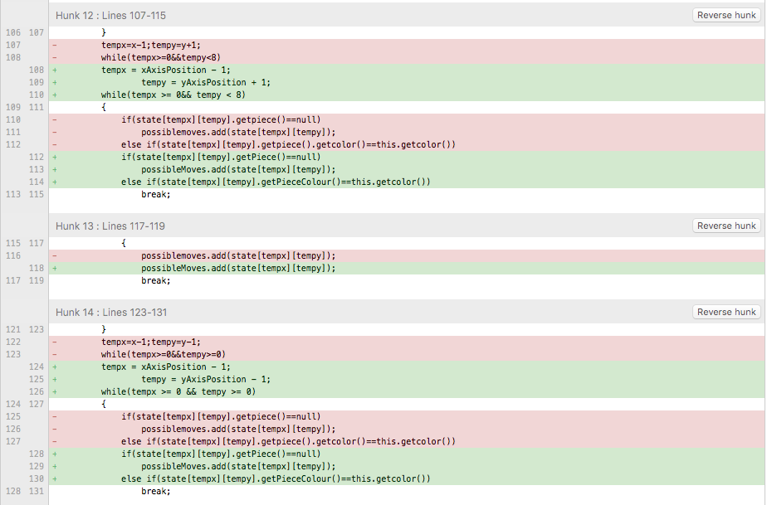

14.f

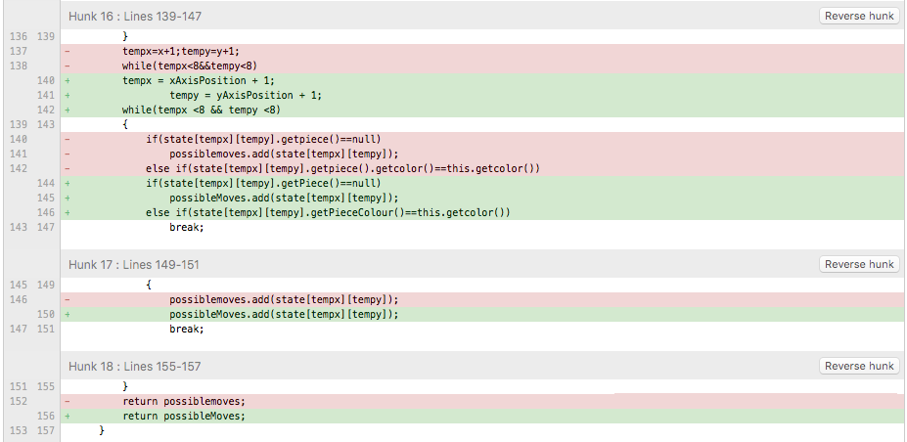

15 – Method Chaining Removed

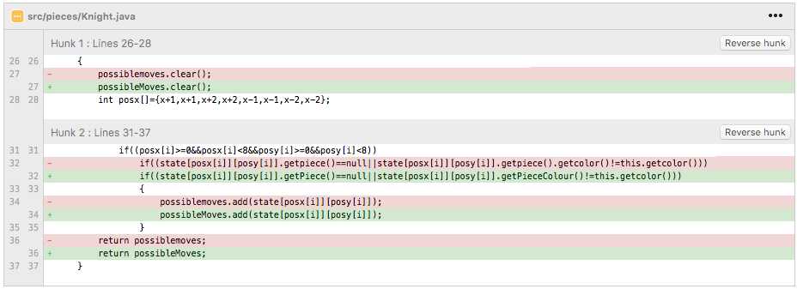

16 – Replace Magic Number with Symbolic Constant

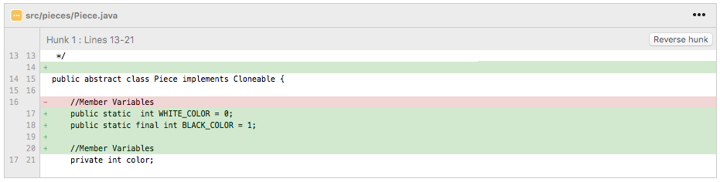

16.a

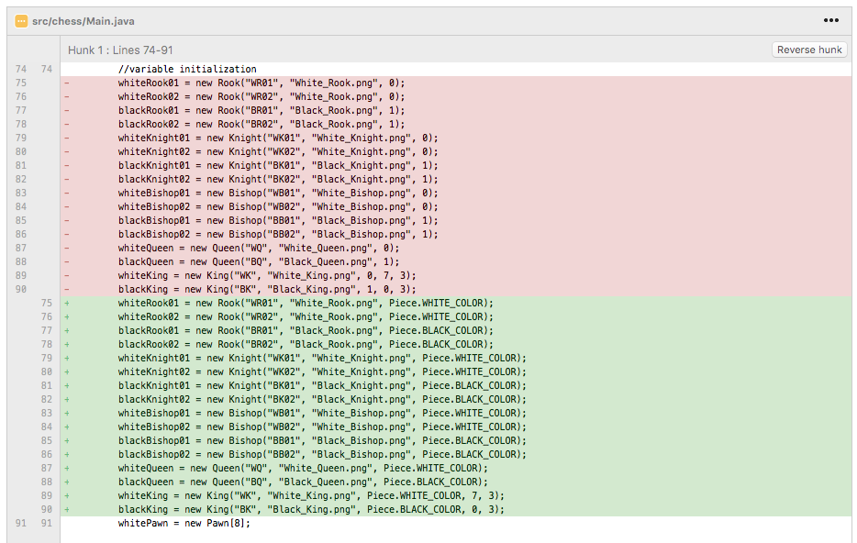

16.a

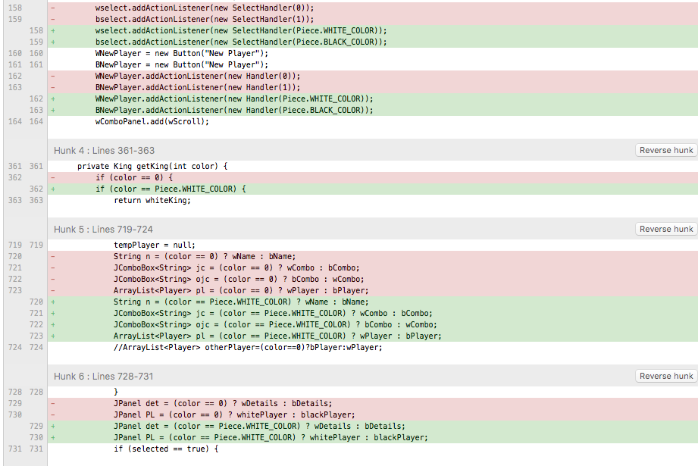

16.a

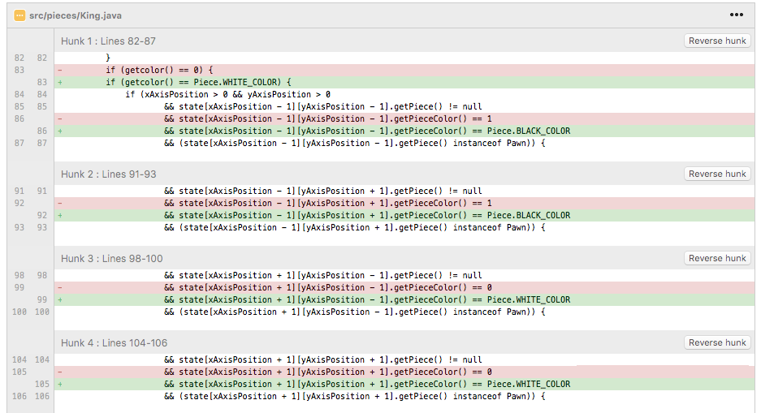

17 – Action level field name changed to improve readability

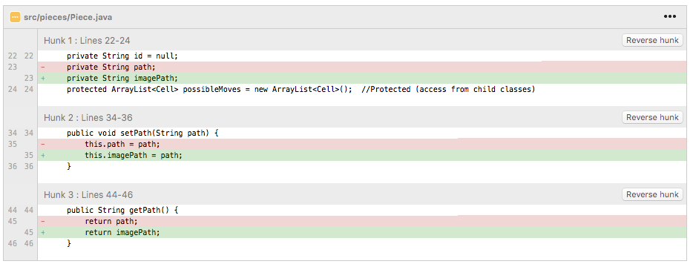

18 – Replace Magic Number with Symbolic Constant

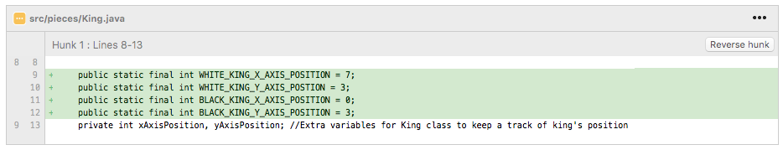

18.a

